SMS Delivery Receipts Forwarder

In Alibaba Cloud SMS, after you call an API operation to send SMS messages, you can use a Message Service (MNS) queue or HTTP URL to receive message delivery receipts.

Currently, if you are using HTTP URL as the recipient, you can only set one URL. For more details can refer to the document here:

<https://www.alibabacloud.com/help/doc-detail/162961.htm?spm=a2c63.p38356.b99.23.131a18cadhF2d3>

In order to allow multiple servers to receive the report using the http URL method. A proxy web server can be used to receive and broadcast the http request.



One easy way to create such proxy is to use Alibaba Cloud Function Compute to host a web application doing the forwarding task.

The following is a sample node js application able to receive a http post request and forward it to multiple http URLs.

Code links…

Function Compute Deployment and Configuration

To deploy the application to Alibaba Cloud Function Compute, please follow the following steps:

In Function Compute console -> Application Center -> Create Web Application

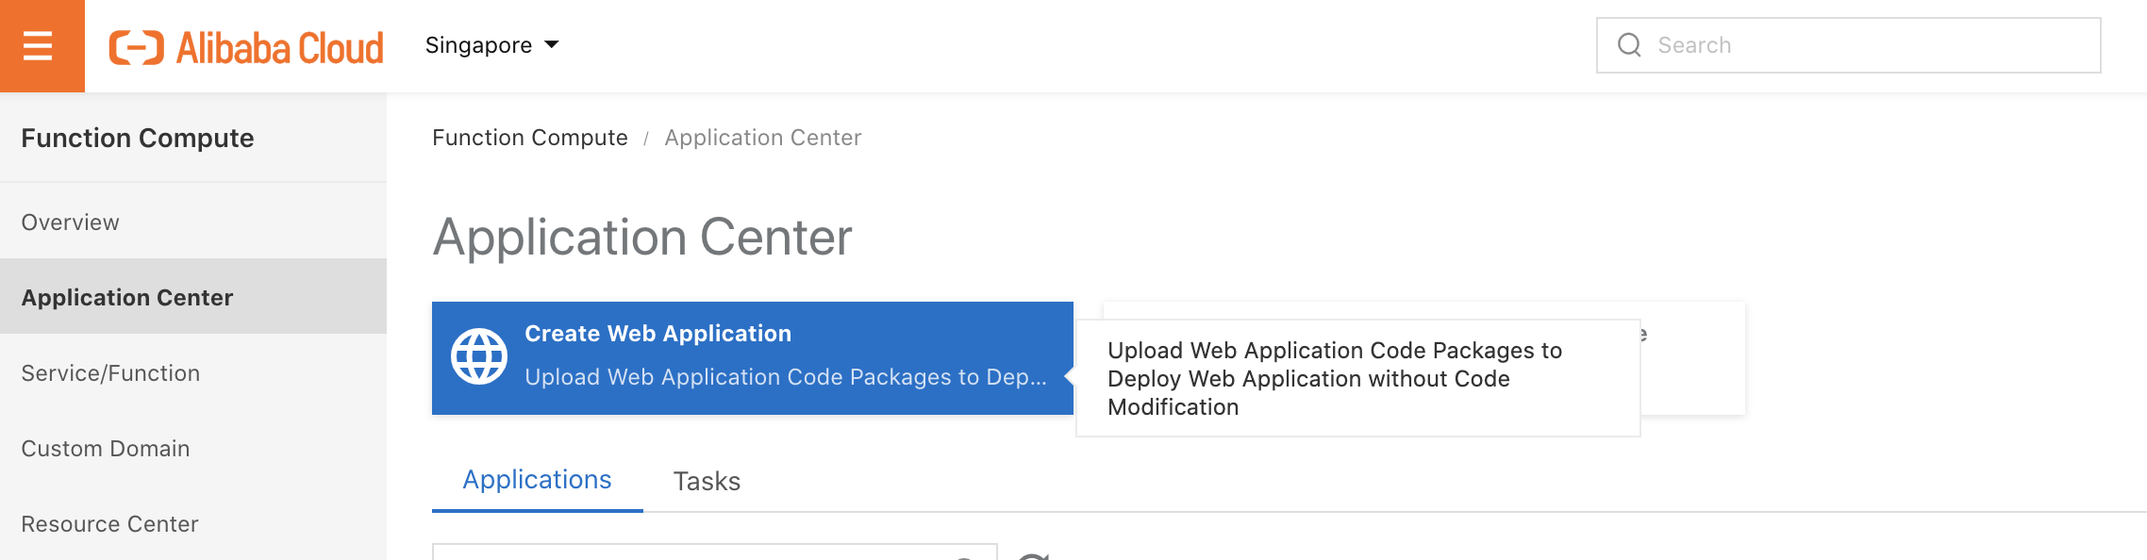

In the create application wizard, follow the blow settings. For Upload file please chose the source code provided. For Application Name you can put any name you prefer.

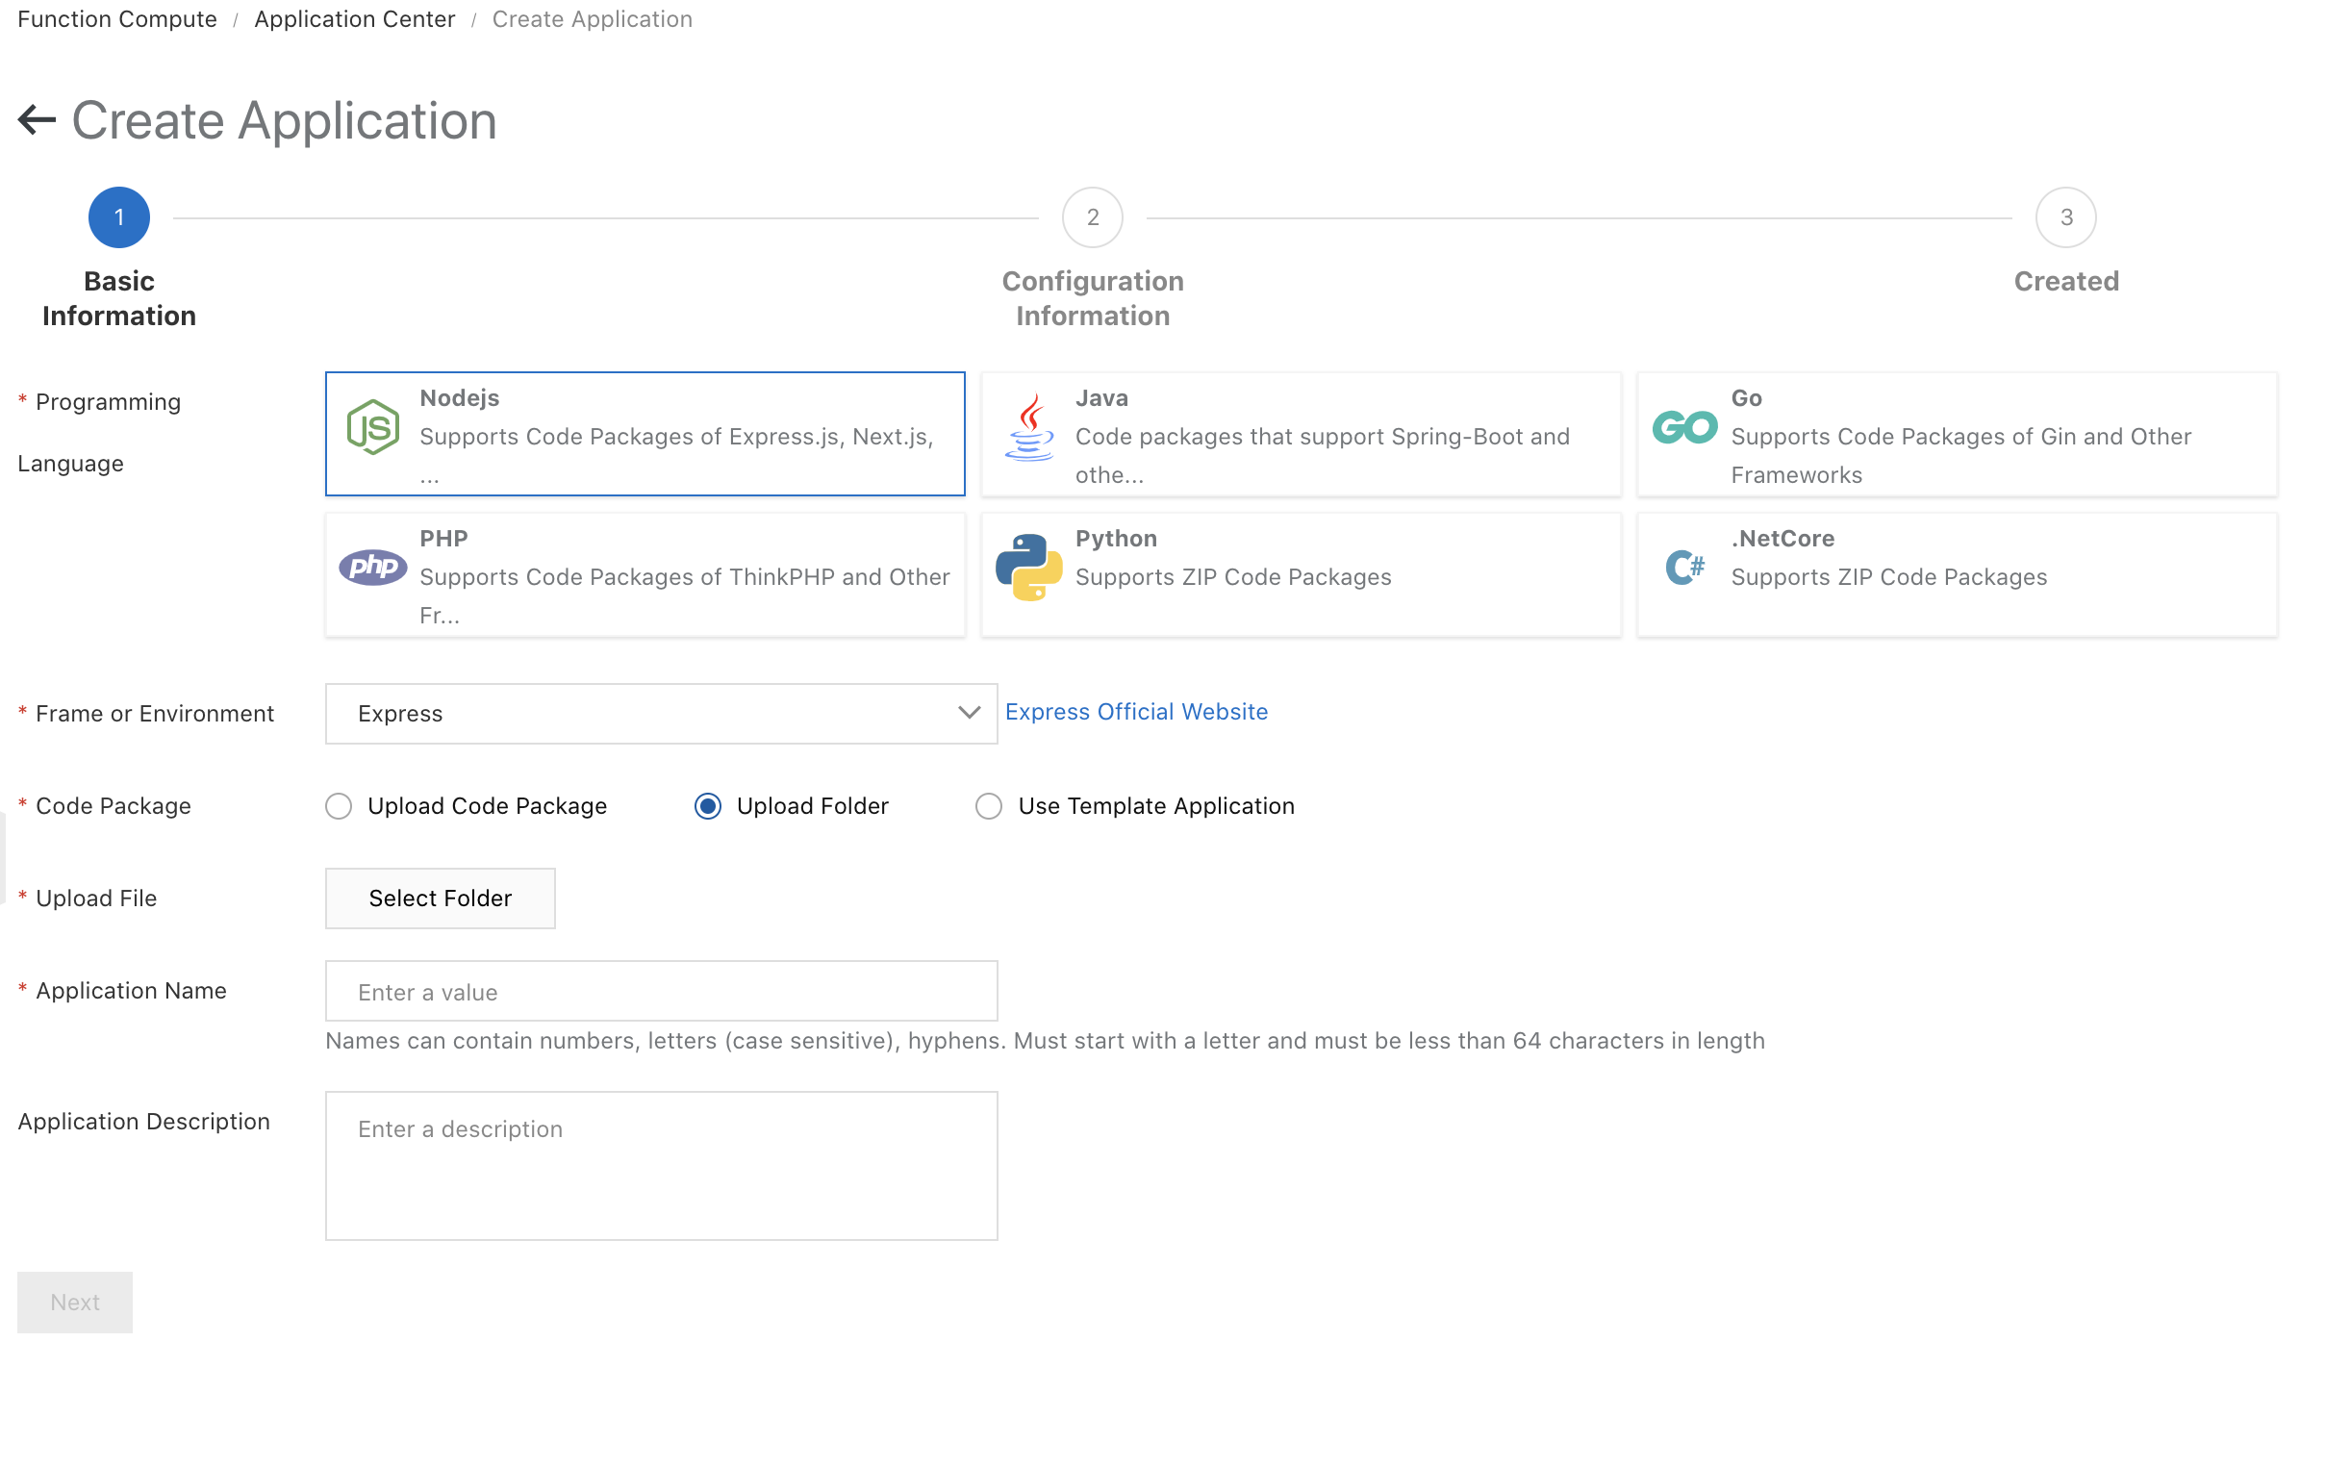

In the next step follow the below settings. Please note that you can input the destinated URLs in the environment variable “URLS”.

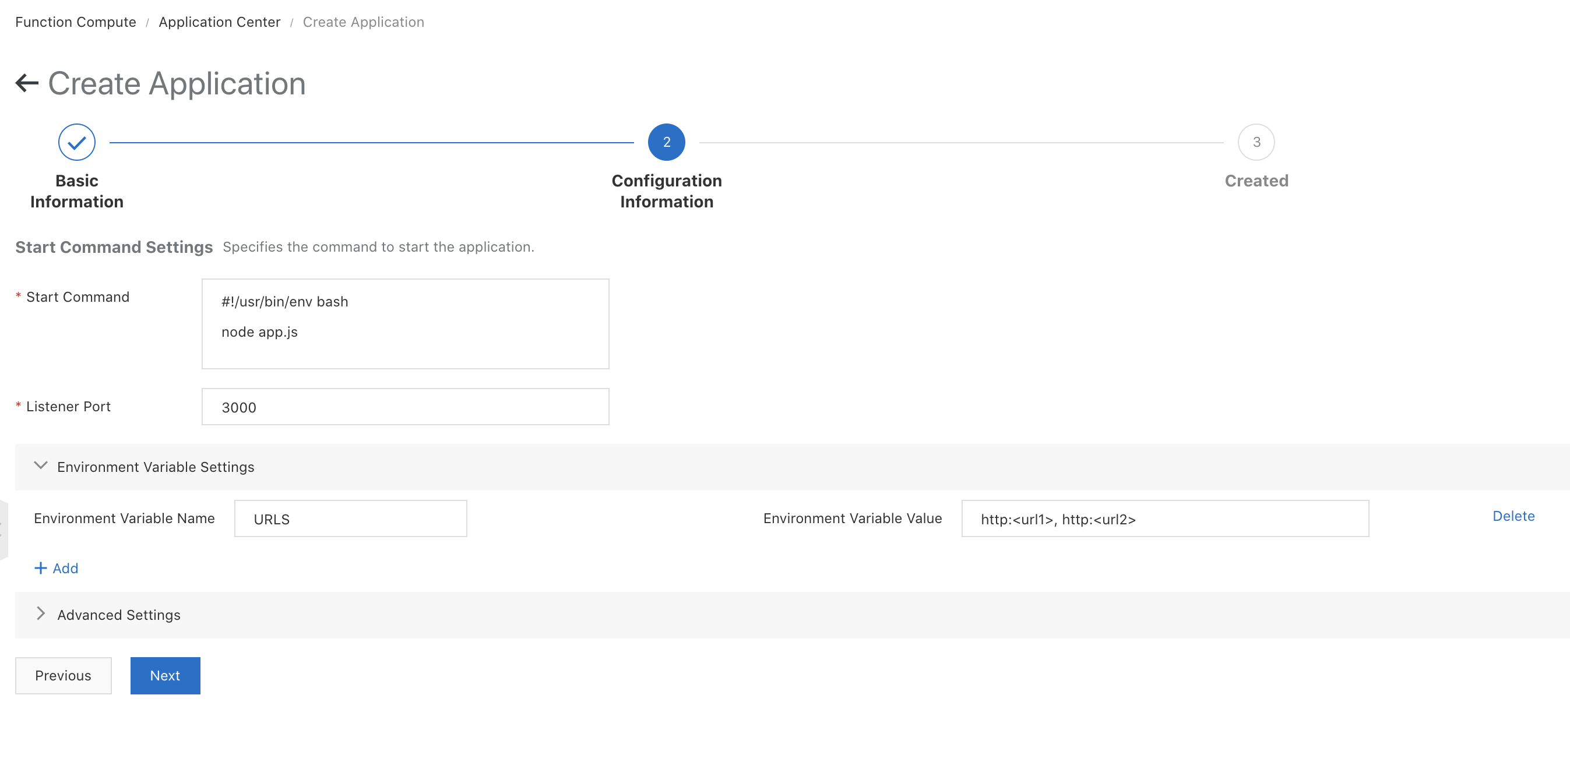

After the code is deployed successfully. In Application Center, chose the application to see the generated Domain Name. You can copy the domain name URL here to the SMS message delivery receipts.

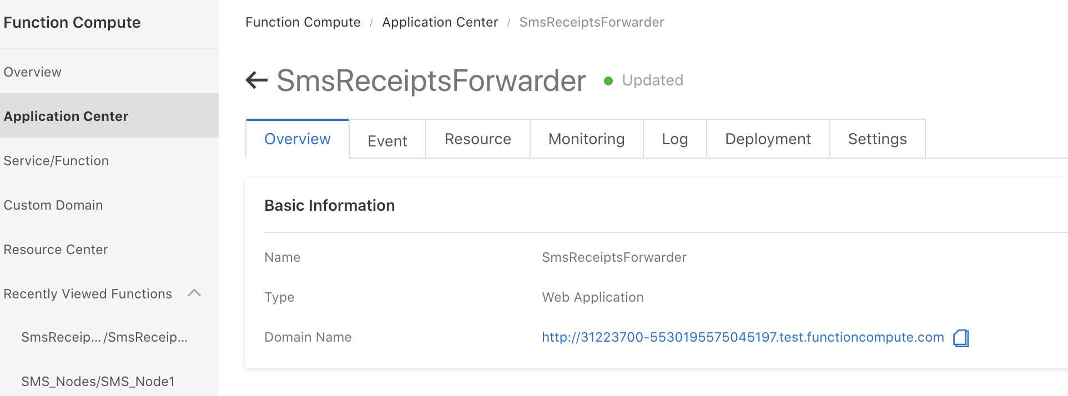

To use a custom domain name, please set in the custom domain menu.

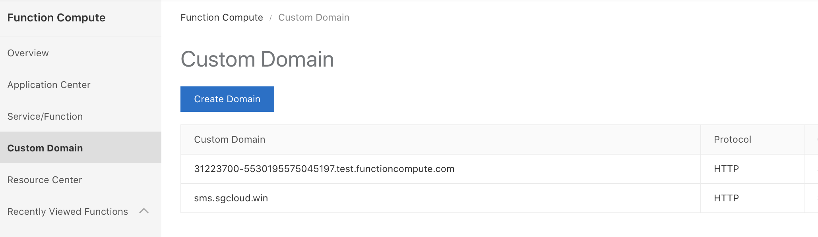

To test the function, you can use POSTMAN with the following setting:

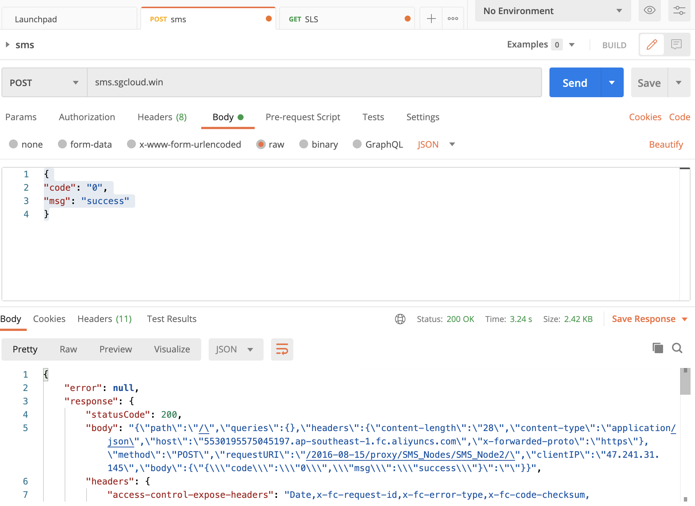

If the function compute is running correctly, you should see the consolidate responses from the servers you posted to.